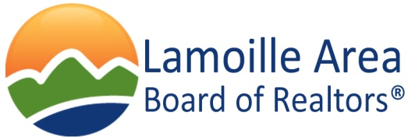

Affiliate Membership Benefits

The REALTOR® brand is one of the strongest and most recognized in the world. The strength of the REALTOR® brand has resulted in significant regulatory wins and legislative initiatives for the real estate industry. As a member of LABOR, you join a group of over 180 fellow REALTORS® and Affiliate Members in Lamoille County with common business needs and interests. Here are just a few of the ways your local dues benefit you:

- Ability to network with our members at all LABOR meetings and events
- Sponsorship opportunities at LABOR meetings and events throughout the year. Sponsorship gives you the chance to highlight your business to the entire LABOR network.
- Company listing on the LABOR website. On this site your company will be available to all REALTORS® needing your services. Also, find up to date property transfers.
- Have the opportunity to advertise your company in the Real Estate Guide that is distributed widely throughout Lamoille and Washington Counties.
- Education offerings for professional development
- Government relations on the local level representing the real estate industry
- Community Outreach program to support the needs of our local community and maintain a professional presence creating an avenue to give back to the community where we live, work and play.
- Opportunity to join the Vermont Realtors association at a reduced rate of $75 once you belong to a local board. This association will connect you with Realtors statewide.

