

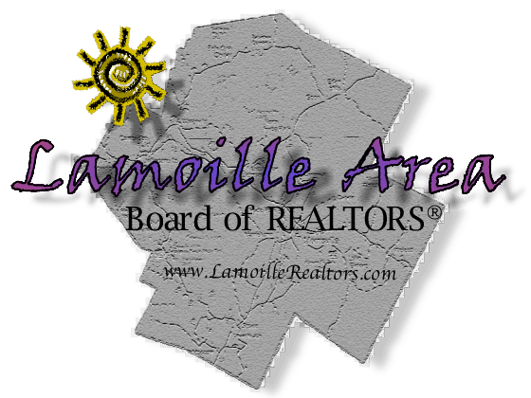**LABOR Membership Benefits**

The REALTOR® brand is one of the strongest and most recognized in the world. The strength of the REALTOR® brand has resulted in significant regulatory wins and legislative initiatives, discounts on continuing education, business services and much more. As a member of LABOR, you join a group of over 100 fellow REALTORS® in Lamoille County with common business needs and interests. You are a part of the larger voice for REALTORS® and the real estate profession in Vermont. Here are just a few of the ways your local dues benefit you:

* Maintain Executive Board and By-laws structure to preserve the certification of the Board in order to serve the needs of its members
* Maintaining database for membership and connection with NAR and VAR
* Meaningful and informative bi-monthly meetings
* Weekly Broker Open House management
* Education offerings for professional development
* Professional Standards and Code of Ethics enforcement
* Robust Affiliate Program for networking and to build business partner relationships.
* Government relations on the local level representing your business interests
* Buyer’s Guide publication for marketing opportunities and raise non-dues revenue
* Community Outreach program to support the needs of our local community and maintain a professional presence creating an avenue to give back to the community where we live, work and play.
* Average of $360 annual savings on MLS fees